**Sheet 10**

Abishek Kumar

Ravikant Tyagi

Erce Can Balcioglu

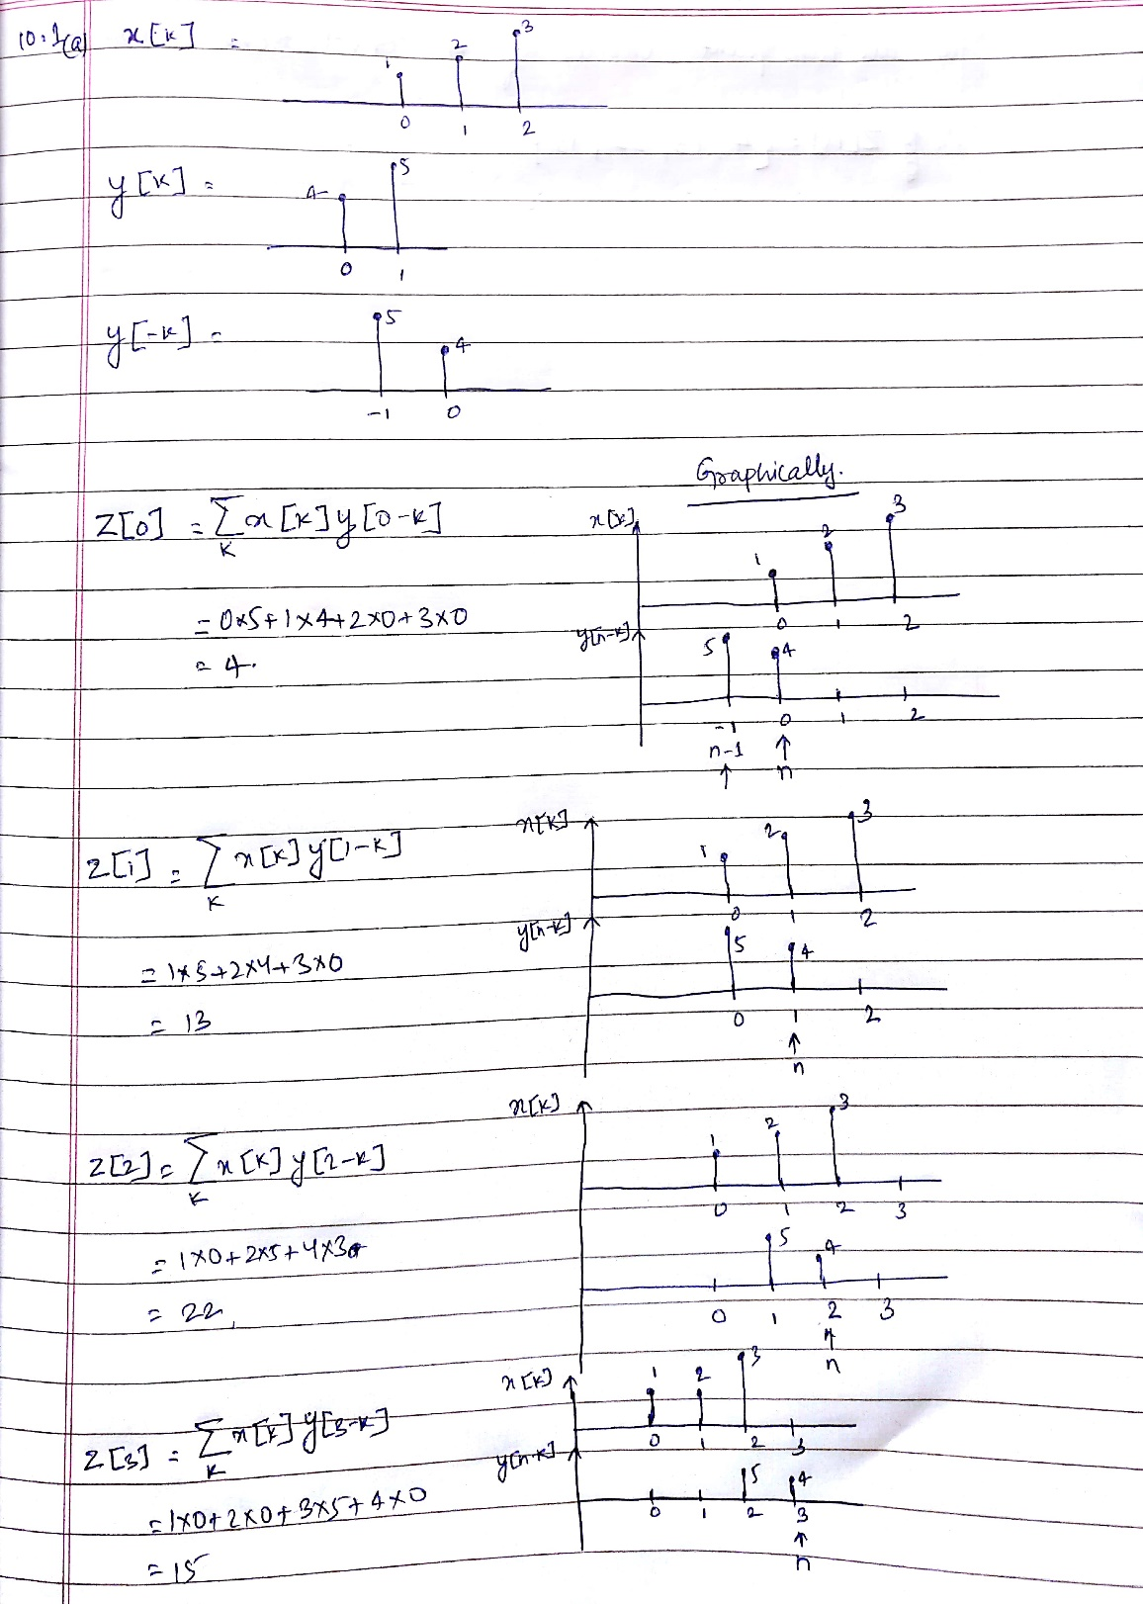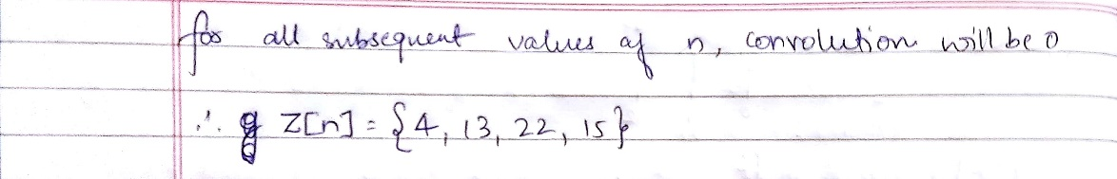

10.1 (b) convolution.m

This is the function which we will be using to calculate convolution

10.1 (c) convolution_script.m

From this we are calling convolution function.

